ST NICHOLAS CHURCH
WARWICK

LONE WORKING POLICY
POLICY
St Nicholas Church is committed to the health, safety and wellbeing of all clergy, lay workers and volunteers who, in the course of their work and ministry, may have to work alone. The purpose of this policy is to ensure that all church volunteers and staff have a safe working environment including when working alone. This policy provides a framework for managing the risks presented by lone working, as well as identifying the responsibilities the PCC and lone workers have in this situation.
This policy relates to all church personnel who work out in the community and/or in other people’s homes, or who work alone in churches or other establishments and are physically isolated from colleagues or family, without access to immediate assistance.
The Church has also adopted a Health and Safety Policy which contains details of the responsibilities and arrangements for the respective parties. All Lone Workers are required to be proactive and familiarise themselves with the Health and Safety Policy. In the case of employees, acceptance of, and adherence, to it forms part of the contract of employment.
This policy is produced in accordance with:
- Section 11.4 of the Parish Safeguarding Handbook produced by Coventry Diocese www.dioceseofcoventry.org
- Safer Environment and Activities produced by the Chrch of England. www.cofe.anglican.org
- The Risk Assessment for Opening Church Buildings to the Public, produced by the Church of England www.cofe.anglican.org
- Coventry Diocese personal risk assessment tool http://www.dioceseofcoventry.org/images/document_library/UDR01559.pdf

PRINCIPLES
It is recognised that lone working is an everyday and unavoidable practice for clergy and church workers, and it is therefore important that the additional risks that arise from this are fully understood, in order that they can go about their daily work in relative safety. This policy should therefore be read in conjunction with the good practice guidance given in the Diocesan Parish Safeguarding Handbook.

All workers and volunteers should avoid working alone if it is not necessary, and work with others where possible. However, if this is not feasible, they should be aware of the importance of personal safety, and take all reasonable precautions to safeguard themselves from harm, as they would in any other circumstances.
Those working or volunteering with children on behalf of the church should avoid situations where they are on their own with a child. This includes ‘formal’ situations such as youth groups, choirs and bell-ringing, and so on, and less formal settings such as before and after those groups, giving lifts home, and so on.
The Parochial Church Council (PCC) is responsible for ensuring that all lone working activities within the church are formally identified, and appropriate risk assessments are undertaken in order to identify and reduce the risks which the lone working activity presents. In drawing up and recording a risk assessment, issues such as the place of meeting, security, the risk of violence and the nature of the task or activity should be considered alongside any other factors appropriate to the circumstances, such as the lone worker’s health and fitness, age and gender. Specific risk assessments should be made for higher risk activity, such as lone working later in the evening or when undertaking work at height or with tools.

The perception of risk can be seen differently by each individual, and, therefore, it is important that all lone workers receive relevant information about the identified risks within their role, in order that they are equipped to recognise these, and are enabled to take responsibility for their own safety and security.

All risks identified to workers arising from lone working should be recorded, in accordance with requirements of the Health and Safety at Work Act 1974, and the Management of Health and Safety at Work Regulations 1999.
PROCEDURE
Personal Safety
Whilst the PCC has a responsibility to ensure their lone workers’ health, safety and welfare, there are also a number of things Lone Workers can do to take reasonable care of themselves:

- Lone workers should never put themselves at risk. If a situation arises that they are unfamiliar with, or in which they feel unsafe, they should withdraw and seek further advice or assistance.
- Staff and volunteers should conduct their own risk assessment on the occasions when they are working alone, which will help them to decide how safe a situation is and what action should be taken to avoid danger. A schema for doing this is given later in the policy.
- Lone workers should be aware of themselves, their behaviour and the signals they may be giving, and to think about their body language, tone of voice and the choice of words they use with others that could be taken as confrontational.
- Lone workers Staff also need to be aware of changes in the behaviour of the person they are with, especially if they seem to become angrier or threatening.
- If an incident occurs – even if it is considered minor – the Lone Worker should make the Leader of event, Vicar and/or Parish Safeguarding Officer know as soon as possible in order that the appropriate risk assessment and follow-up action can be taken
- Staff and volunteers should take every reasonable precaution to ensure that they do not disclose their personal details, such as address and telephone number or their social networking profile, without good reason and bear mind what information about them is already in the public domain.

Persons must not work on their own unless they have a means of communication with them and have notified a colleague of the details of the work being undertaken and agreed a procedure to ensure their safety is checked on.

When working alone in St. Nicholas’ Church, volunteers and staff should:
- Tell someone where they are working.
- In advance advise a family member, friend or colleague of their estimated arrival time home
- Carry a mobile phone. Consider carrying a personal alarm.
- Lock any doors behind them if appropriate.
- Use Handrails where available
- Carry keys so that they can leave by another exit if necessary.
- Not agree to meet anyone in an isolated place.
- Be alert to possible dangers and minimise them – for example keep lights on until a building is completely vacated;
- Ensure entry and final exits are made through well-lit routes (leave as early as possible in the evening not late at night)
- If in a group the last person to leave should ask for another member of the group to help them lock up rather than leave alone
- Be alert to unusual activity or gatherings around the premises and if uncomfortable with a situation should ring Police
- Do not disturb a rough sleeper within the grounds of the church.
- Inform the Church warden or Vicar of any suspicious behaviour noted or any threats made to them.
- Report any defects to the building such as trip hazards etc. to the Churchwarden or church warden assistants
- Report any incidents to the Churchwarden via the Church Office.
Personal Safety Risk Assessment
Use this to assess your environment, and your working practices, as well as for an instant assessment of a situation.
From Personal Safety at Work, Suzy Lamplugh Trust 2006, revised 2008
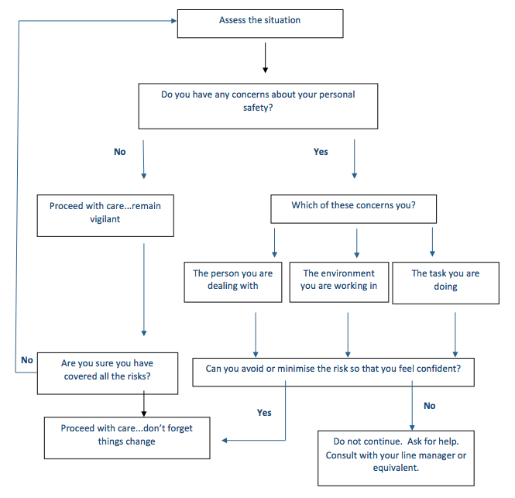Working Alone in Church or at another Building
Within this document, lone working refers to situations where individuals, in the course of their duties, work alone or are physically isolated from colleagues and without access to immediate assistance.
In this regard, the PCC has:
- Consulted Lone Workers by means of a questionnaire and undertaken a risk assessment on building safety to determine if the church/building needs extra security. Lone Workers confirmed that there were no additional safety measures required.
- Consulted Lone Workers and considered how lone workers will raise the alarm if necessary, and ensured they have a means of communicating with others in the event a problem arises. All Lone Workers confirmed they have access to a mobile phone which is carried with them when lone working.
- Confirmed that Lone Workers usually lock the door of the church whilst lone working. An individual protocol will be agreed with any individual who is not able to lock the door due to the activities undertaken.
- Confirmed that all lone workers have read the St Nicholas Safeguarding Policy.

No worker should ever plan to be alone on church premises with children or young people. However, if they should find themselves in this situation, it is important that another adult is made aware immediately. The worker should also assess the risks involved in sending the child or young person home, against the risks and vulnerability of being alone with them.
Home Visits
Visiting vulnerable adults in their homes is an essential element of many church ofﬁcers’ roles. Many parishioners will be well known to the church ofﬁcer and where there have been no previous concerns, the level of risk to the church ofﬁcer or parishioner during visits will usually be low. However, unexpected circumstances can be encountered, some of which may place a church ofﬁcer at risk. For example, the unexpected presence in the home of a relative or friend with a history of violence or threatening behaviour. Unfortunately, case histories also show that a parishioner may be at risk from a church ofﬁcer. For these reasons it is very important for parishes to ensure their church ofﬁcers and parishioners are as safe as they can be, and that there is accountability and transparency in the manner in which church ofﬁcers engage in lone working or visits to homes.
To assure the person you are visiting of their safety, and for your own as a church ofﬁcer:
- If possible, undertake a risk assessment before an initial visit, especially if you do not know the person. If there are any concerns or risks known before a visit is made, you are advised always to undertake a risk assessment (see Model Risk Assessment Checklist for Home Visiting). In these circumstances, consider whether the visit is necessary, or whether you should be accompanied by another church ofﬁcer. In addition, visiting in pairs may be advisable, especially if the adult is perceived to be vulnerable.
- Do not call unannounced; call by appointment, if appropriate telephoning the person just before visiting.
- Be clear about what support you can offer and the purpose and limitations of any pastoral care/support that is available.
- Do not make referrals to any agency that could provide help without the adult’s permission, and ideally encourage them to set up the contact, unless there are safeguarding concerns.
- Never offer ‘over-the-counter’ remedies to people on visits or administer prescribed medicines, even if asked to do so.
- Do not accept any gifts from adults other than token items, to avoid misunderstandings or subsequent accusations from the person or their family. If someone wants to make a donation to the church, put it in an envelope, mark it on the outside as a donation and obtain a receipt.
- Make a note of the date when you visit people, report back about the visit to the agreed named person and say what is concerning or going well.
- Report safeguarding concerns to the Parish Safeguarding Ofﬁcer. Sally Howells and/or Vicar, Rev Linda Duckers or directly to the Diocesan Safeguarding Advisor if they are not available.
RECORDS
Clergy and church workers should keep a regular record of pastoral encounters, including details such as date, time, subject and actions to be taken. It is important to keep factual records, and separate these from any opinions expressed.
All records should be held in a secure, locked cabinet in the parish and retained in line with the guidance provided in the Diocesan Safeguarding Handbook.

REVIEW
St Nicholas Church Lone Working Policy will be reviewed and may be revised annually in response to new legislation, safeguarding policies or guidance, or specific demand and feedback.
Contact details for the Diocesan Safeguarding Advisor can be found at http://www.dioceseofcoventry.org/Safeguarding

